Year 12

Physical Education Studies

Biomechanics

Newton’s 2nd Law of Motion

* “The rate of change of acceleration to a body is proportional to the force applied to it, and inversely proportional to the mass of the object.”
* F=m\*a
* E.g. given that both sprinters exert the same amount of acceleration, the sprinter that weighs more will travel faster than the lighter athlete

Conversation of Linear Momentum

* The total momentum of two objects before and after impact are equal
* Occurs where a perfectly elastic collision takes place

Newton’s Third Law

* For every action there is an equal or opposite reaction
* Eg. the force exerted by a backstroker pushing into the wall at the beginning of the race will push the backstroker in the opposite direction with the same amount of force

Impulse-Momentum relationship

* The longer the force is applied, the greater the impulse
* The shorter the force is applied, the shorter the impulse

Impulse and Sport

* Increasing momentum
  + Eg. hockey
    - Strong hit (lots of force), small period of time = increase
    - Long hit (less force), long period of time = increase
* Decreasing momentum
  + Eg. catching a ball
    - Increase in time to reduce peak force therefore decreasing momentum

Coefficient of Restitution

* COR measures the elasticity of the collision between an object and given surface
* COR of 1 = perfectly elastic meaning that when dropped, the object returns to that height
* COR of 0 = perfectly inelastic meaning that when dropped, the object does not bounce
* Measured by the square root of the height bounced over the height dropped

Factors affecting COR

* Equipment and Materials
* Temperature of the ball

Forces that create Angular Rotation

* Angular rotation is caused by the application of an eccentric force
* When only 1 eccentric force is applied to the object, both linear and angular motion occur
* To increase angular rotation one can either
  + Increase the amount of force applied
  + Increase the distance from the acis by which the force is applied
* Force couples
  + Two equal forces act on opposite sides of the axis

Conversation of Angular Momentum

* Means that a spinning body will continue spinning indefinitely unless an external force acts on it
* Angular momentum remains constant even if angular velocity and moment of inertia fluctuate and change

Levers

* 1st class
  + axis in the middle
  + eg. seesaw
* 2nd class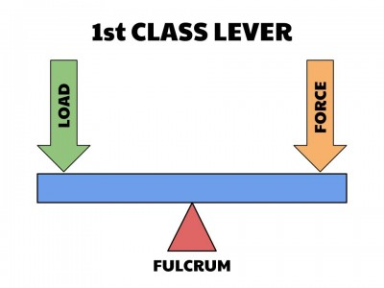
  + resistance (interchangeable with load) in the middle
  + eg. pushup
* 3rd class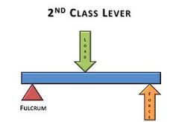
  + force in the middle
  + eg. bicep curl, golf club, baseball bat, tennis racquet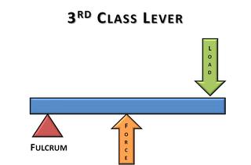
* Force increased by making the force arm longer than resistance arm
* Speed increased by making force arm shorter than resistance arm

Factors affecting Levers

* Length
* Inertia
* Amount of force

Fluid Mechanics

* Fluids of interest
  + Water and Air
* Fluid forces have little effect on some objects (shot put) but major effects on other objects (shuttlecock)
* Major fluid forces of interest
  + Drag
  + Lift
  + Buoyancy

Drag and Lift

* Inverse relationship
* The greater the disturbance to the fluid, the greater the transfer of energy from object to fluid
* 2 factors affecting fluid resistance:
  + Density
    - Eg. humid conditions will increase fluid resistance
  + Viscosity
    - Eg. honey as opposed to water, water as opposed to air

Surface Drag

* Friction produced between fluid and surface of a moving object
* Factors affecting:
  + Relative velocity of moving object
  + Relative roughness of surface object
  + Viscosity of fluid
  + Surface area of the object

Form Drag

* Resistance created by pressure differential between front and back of an object moving through a fluid
* Factors affecting:
  + Cross sectional area of object
  + Velocity of object
  + Surface roughness
  + Shape of object

Wave Drag

* Resistance formed by creation of waves at the point where air and water interact
* Factors affecting:
  + Relative velocity of wave
  + Technique
  + Open water vs closed condition

Boundary Layer

* Thin layer of air surrounding or attached to the ball
  + Laminar – smooth, slow moving ball
    - Early boundary separation
    - Large pressure differential
  + Turbulent – rough, fast moving ball
    - Later boundary separation,
    - Smaller pressure differential
* Separation
  + Where boundary layer breaks from ball
  + Earlier separation occurs, the greater the pressure gradient between the front and back of the ball
* Factors
  + Velocity
  + Surface Roughness

Factors affecting drag

* Drag Coefficient
* Cross Sectional Area
* Speed
* Surface Roughness
* Mass
* Shape

Environmental Factors Affecting Drag

* Air Density
* Atmospheric Pressure
* Humidity
* Temperature

Buoyancy

* Archimedes Principle
  + The buoyant force acting on an object Is equal to the weight of the fluid displaced by the object
* Positive buoyancy
  + Float
* Negative Buoyancy
  + Sink
* Neutral buoyancy
  + Suspends

Bernoulli’s Principle

* Velocity is inversely proportional to pressure
  + High velocity = low pressure
* Lift occurs when there’s higher pressure below the object

Magnus Effect

* Term used to describe the effect of rotation on an object’s path as it moves through a fluid

Top spin

* High pressure on top of the ball causing it to dip faster

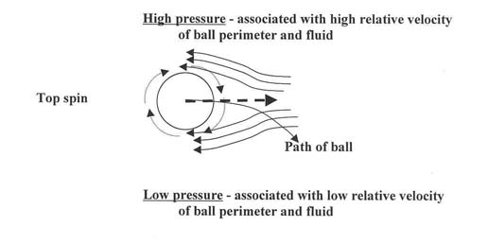

Back Spin

* High pressure of the bottom of the ball causing it to float

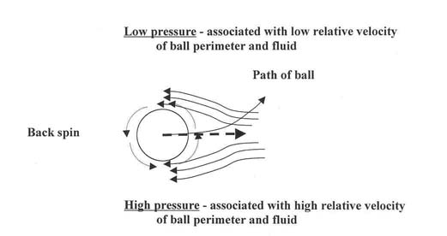

Side Spin

* High pressure on one side of the ball causing it to curve the other way

Formula’s to remember:

Force = mass\*acceleration (F=m\*a)

Momentum = mass\*velocity (P=m\*v)

Impulse = force\*time (I=f\*t)

Torque = force\*distance from axis of rotation (t=f\*d)

Moment of inertia = mass\*radius of rotation

Angular Momentum

* Angular velocity\*moment of inertia
* Moment of inertia = mass\*radius of rotation